
Saint Mary University

Rapid Application Development

Chat App <->
Group Project

Group Members:
- Betel Fasika
- Biruk Getu
- Fasika Bekele
- Kibru Genene
- Meron Zeradawit

Submitted To – Mr. Dagmawi Yewlsew

Introduction
This chat application is a web-based communication platform designed for real-time messaging. It enables instant messaging, adding contacts for conversations, making it ideal for collaboration.

1 - Significance of the System

The proposed chat application will serve as a real-time communication tool that enhances connectivity among users. Its significance includes:
- Facilitates instant messaging, allowing users to communicate effectively regardless of their location.
- Allows to chat friends and provide messaging features.
- Can be adapted for customer support or team collaboration, increasing productivity in professional environments.

2 - Development Environment and Tools

The development environment and tools chosen includes:
- Programming Languages:
  - Frontend: Razor Pages
  - Backend: C#
- Database:
  - SQL: My-SQL
- Real-Time Communication:
  - Framework: Signal-R
- Development Tools:
  - IDE: Visual Studio and Visual Studio Code

3 - Scope and Limitations

Scope:
- User registration and authentication.
- One-on-one chat functionalities.
- Text messaging.
- Adding Contacts using Phone Number.
Limitations:
- Initial focus on text messaging only.
- Dependency on internet connectivity; offline features are not included.
- Privacy and security measures may need further development for sensitive information.

4 - Functional Requirements

- User Management:
  - Users can register, adding contacts, log in, and log out.
- Messaging:
  - Send and receive real-time messages.
  - Support for basic text formatting.
  - Create and manage group chats.
- Search:
  - Search for contacts.
- Management
  - Administrators can see the clients connected and using the application.

2.1 Actors and Their Roles
User
The User represents an individual who interacts with the chat application to communicate with others. Users can create accounts, log in, and participate in chats.
What they do:
- Register, log in, and log out of the system.
- Send and receive messages (one-on-one).
- Manage their chats.

Administrator
The Administrator (Admin) represents the system's overseer and manager, responsible for maintaining the functionality, security, and overall health of the chat application. They ensure that user accounts comply with policies, manage chat rooms, and monitor communication for inappropriate or harmful behaviour.
What they do:
- Monitor chat activity for security and policy compliance.

  - Use Case Diagram

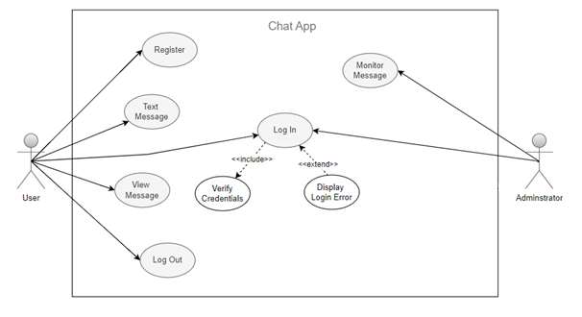

  - Activity Diagram
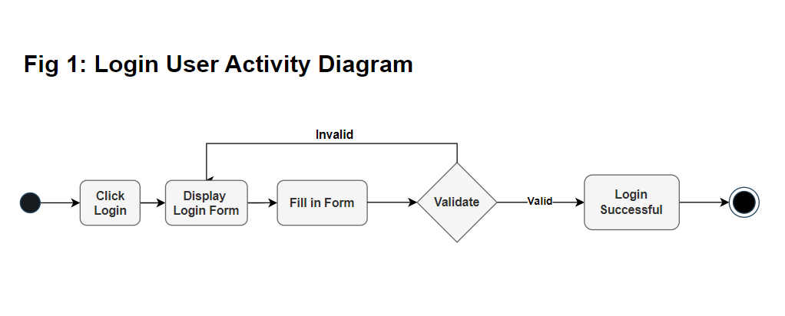
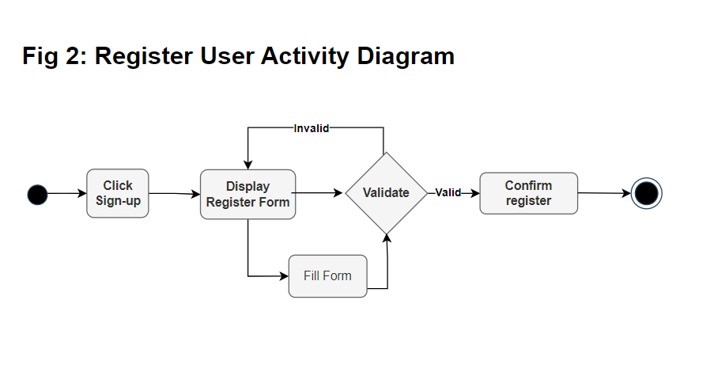
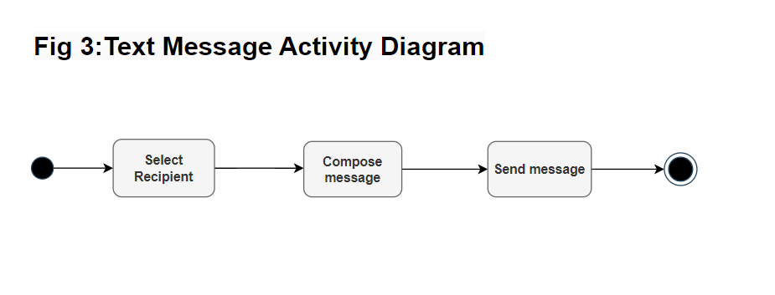
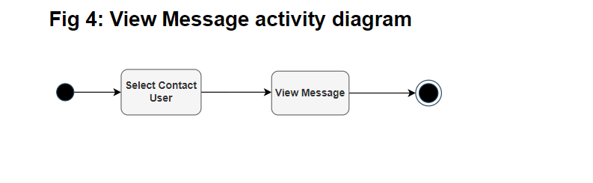

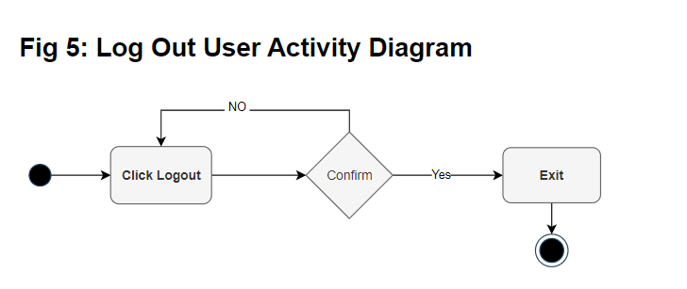
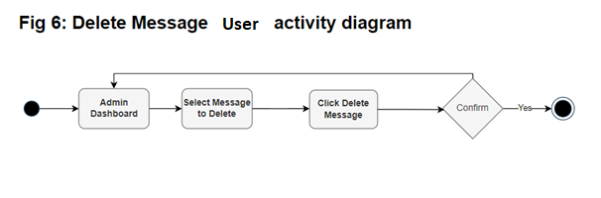

  - Sequence Diagram
- User Login Sequence Diagram
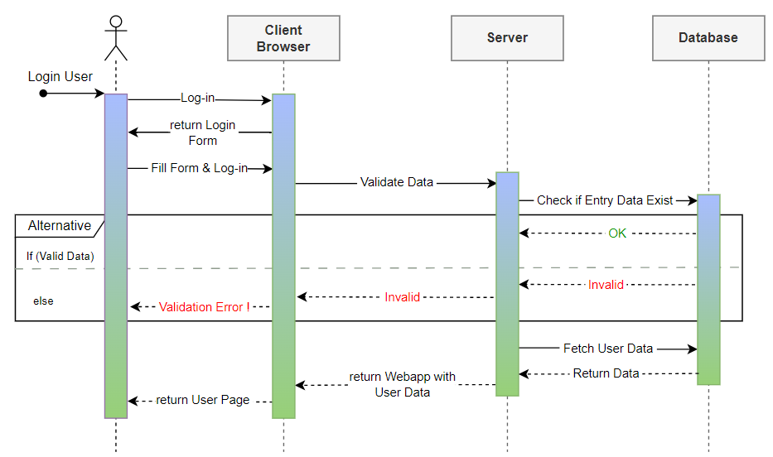

- User Register Sequence Diagram
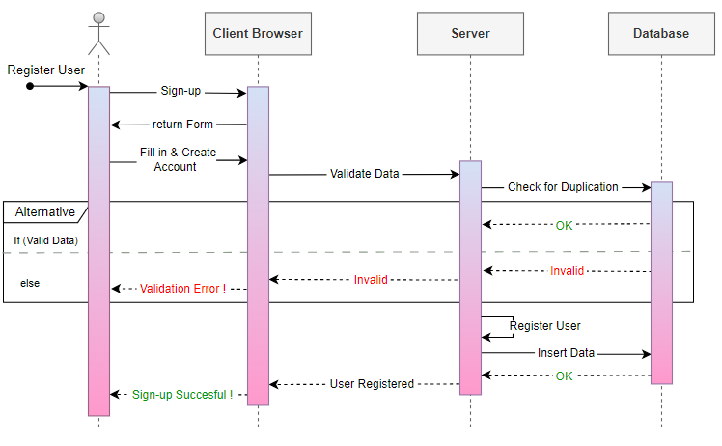
- User Text Message Sequence Diagram
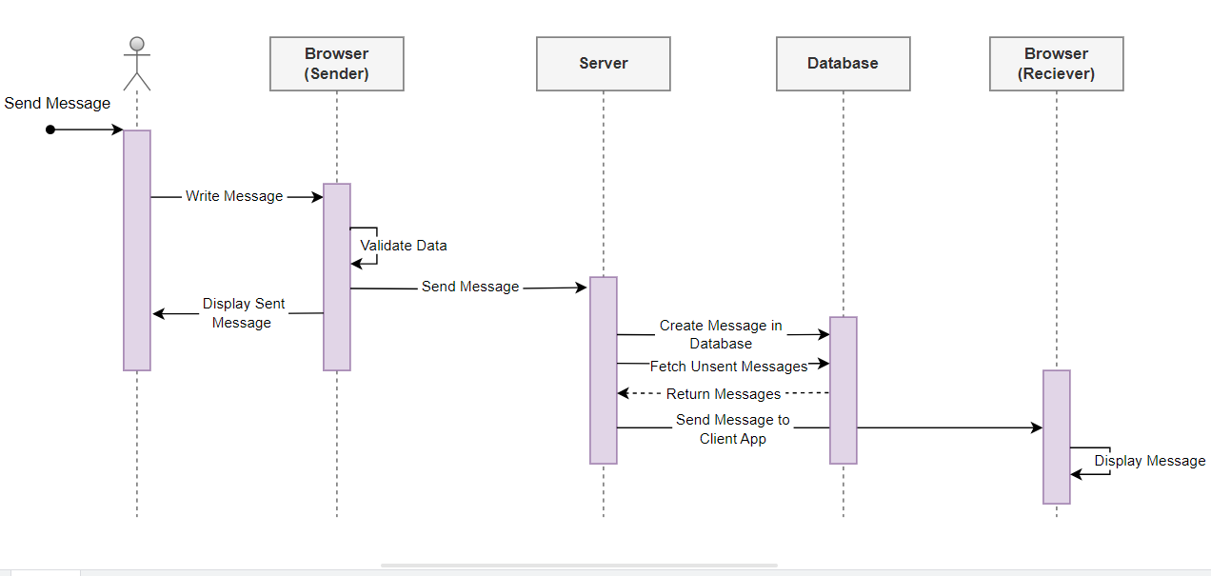

- User Delete Message Sequence Diagram
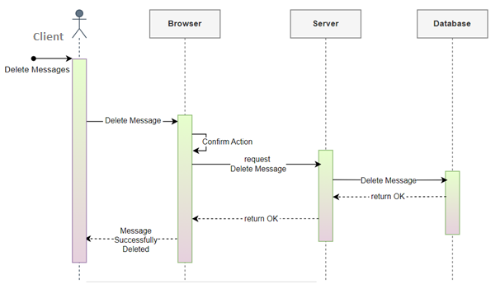

Class Diagram

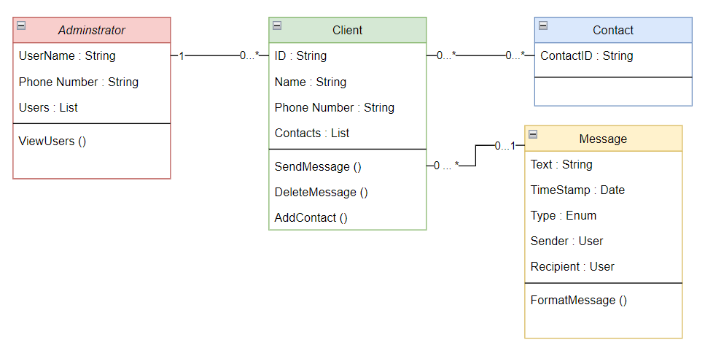

  - Admin: Manages users and contacts.

  - Client: Users who send and receive messages.

  - Contact: Represents a user's contacts.

  - Message: Represents the messages exchanged between users.

Database ER Diagram
